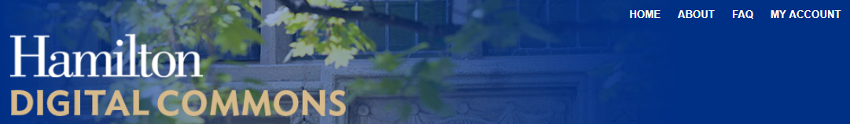
for Students
The Hamilton Digital Commons (https://digitalcommons.hamilton.edu) is an open archive for scholarly and creative works by faculty, students and staff.
What types of student works might be included in the Digital Commons?
- theses and capstone projects
- prize-winning submissions for college awards
- grant-funded research
- course projects
- Hamilton student publications

What are some examples of student work in Digital Commons repositories?
- course projects – Hamilton (http://digitalcommons.hamilton.edu/books/13)
- honors theses – Bates (http://scarab.bates.edu/honorstheses/222)
- public readings – Hamilton (http://digitalcommons.hamilton.edu/applequill)
- posters – Colby (http://digitalcommons.colby.edu/clas/2015/program/462)
How are student works selected for inclusion in the Digital Commons?
Student contributions to the Hamilton Digital Commons are recommended for inclusion by a faculty member, an academic department, or a Hamilton office for whom the work was produced.
Who can access student work in the Digital Commons?
The information page that includes a bibliographic description of the work (i.e., author, title, date, medium, abstract, academic department, faculty advisor, etc.) is visible to anyone with an internet connection. The works themselves may be made available for viewing or download to everyone, or be:
- limited to individuals accessing the internet from the Hamilton campus
- limited to individuals with a hamilton.edu email address
- limited to the Hamilton Digital Commons administrator, who can download and share documents upon request
It is also possible to place embargos on student works to make them unavailable to the public for a specified period following their submission.
What are the terms of use for works made available in the Digital Commons?
Materials in the Hamilton Digital Commons are made available for educational and research purposes only under a Creative Commons BY-NC-ND 4.0 license. Acceptable uses include personal study, distribution to students, research, and scholarship (including computational research uses such as data and text-mining, citation-extraction, or cross-referencing). In using this material, individuals agree to the following:
- Attribution — You must give appropriate credit, provide a link to the terms of use, and indicate if changes were made. You may do so in any reasonable manner, but not in any way that suggests the author or Hamilton College endorses you or your use.
- Non-Commercial — You may not use the material for commercial purposes.
- No Derivatives — If you remix, transform, or build upon the material, you may not distribute the modified material.
Any additional restrictions or permissions beyond those granted under these terms of use are noted on the information pages accompanying individual works.

What do students agree to when submitting their work to the Digital Commons?
All individuals who contribute work to the Hamilton Digital Commons agree to the following:
I, as a creator of this work, grant Hamilton College permission to share the work in an open-access digital environment intended for educational purposes. I give Hamilton College permission to make this work available to all users and to migrate it to accessible formats as necessary. I have ensured that necessary copyright permissions have been cleared.
I and any co-authors retain all intellectual property rights to the work that are under our control at the time of its submission. Requests for use of this work for purposes other than education will be referred back to me as copyright holder.
How can I learn more?
For more information about the Hamilton Digital Commons, contact Reid Larson, Research and Scholarly Communication Librarian, at rslarson@hamilton.edu or 315-859-4480.

